1. LIBRARY MANAGEMENT SYSTEM:
SOURCE CODE:
```html
<!DOCTYPE html>
<html>
<head>
<title>Library Management System</title>
<style>
body{font-family:Arial;background:#f1f5f2;margin:0}
header,nav,footer{background:#145a42;color:white;padding:15px;text-align:center}
nav a{color:white;margin:8px}
section{background:white;margin:15px;padding:15px;border-radius:8px}
input,button,select{padding:8px;margin:5px}
button{background:#145a42;color:white;border:0;cursor:pointer}
</style>
</head>
<body>
<header>
<h1>Library Management System</h1>
</header>
<nav>
<a href="#home">Home</a>
<a href="#books">Books</a>
<a href="#login">Login</a>
<a href="#admin">Admin</a>
<a href="#history">History</a>
<a href="#materials">Materials</a>
<a href="#contact">Contact</a>
</nav>
<section id="home">
<h2>Welcome to Our Library</h2>
<p>Search books and manage library resources.</p>
</section>
<section id="books">
<h2>Search Books</h2>
<input id="search" placeholder="Enter book name">
<button onclick="searchBook()">Search</button>
<div id="result"></div>
</section>
<section id="login">
<h2>Student Login</h2>
<input placeholder="Email"><br>
<input type="password" placeholder="Password"><br>
<button onclick="alert('Demo login')">Login</button>
<button onclick="alert('Registration page demo')">Register</button>
</section>
<section id="admin">
<h2>Librarian Admin</h2>
<input id="book" placeholder="Book name">
<button onclick="addBook()">Add Book</button>
<div id="list"></div>
</section>
<section id="history">
<h2>Borrow History</h2>
<p id="historyList">No books borrowed.</p>
<p>Issue Date: Today | Return Period: 14 days</p>
<p>Fine: ₹10 per overdue day (demo policy)</p>
</section>
<section id="materials">
<h2>Study Materials</h2>
<select id="year">
<option>1st Year</option>
<option>2nd Year</option>
<option>3rd Year</option>
<option>4th Year</option>
</select>
<select id="sem">
<option>Semester 1</option>
<option>Semester 2</option>
<option>Semester 3</option>
<option>Semester 4</option>
<option>Semester 5</option>
<option>Semester 6</option>
<option>Semester 7</option>
<option>Semester 8</option>
</select>
<p>Notes and PDFs can be added here.</p>
</section>
<section id="contact">
<h2>Contact Library</h2>
<input placeholder="Your name"><br>
<input placeholder="Your email"><br>
<input placeholder="Your message">
<button onclick="alert('Message submitted in demo mode')">Send</button>
</section>
<footer>
<p>© 2026 Library Management System</p>
</footer>
<script>
let books=["Java Programming","Python Basics","Web Technology"];
function displayBooks(data){
result.innerHTML=data.map(b=>
`<p>${b} <button onclick="borrow('${b}')">Borrow</button></p>`
).join("");
}
function searchBook(){
let q=search.value.toLowerCase();
displayBooks(books.filter(b=>b.toLowerCase().includes(q)));
}
function addBook(){
if(book.value){
books.push(book.value);
list.innerHTML=books.map(b=>`<p>${b}</p>`).join("");
displayBooks(books);
book.value="";
}
}
function borrow(b){
historyList.innerText="Borrowed: "+b+" | Issue: Today";
alert("Book issued successfully!");
}
displayBooks(books);
</script>
</body>
</html>
```
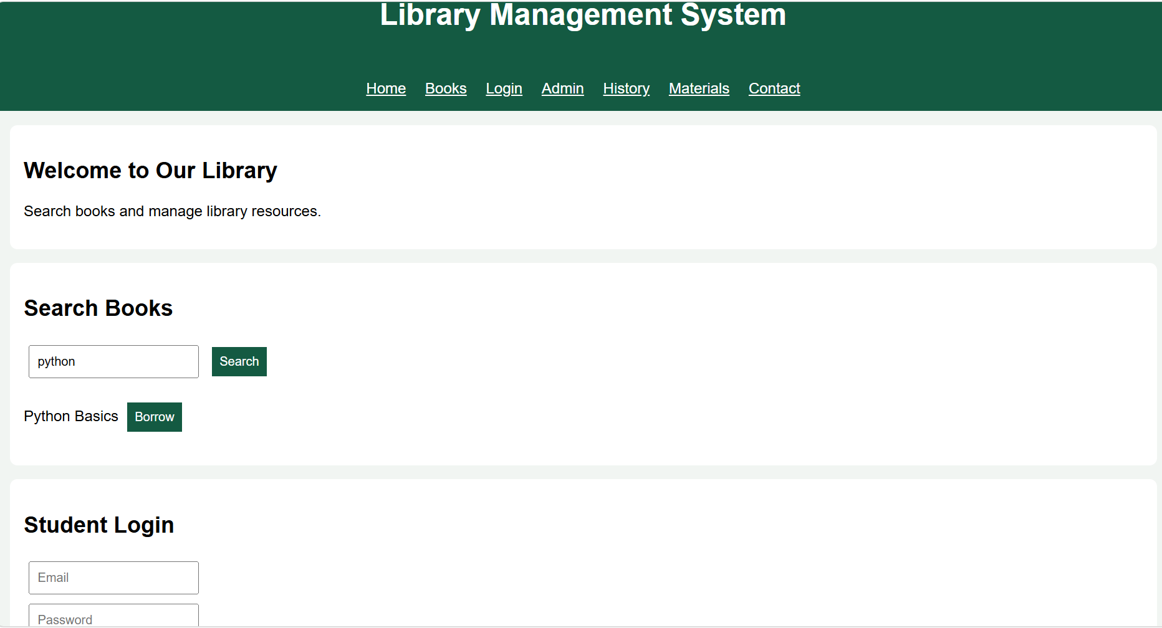
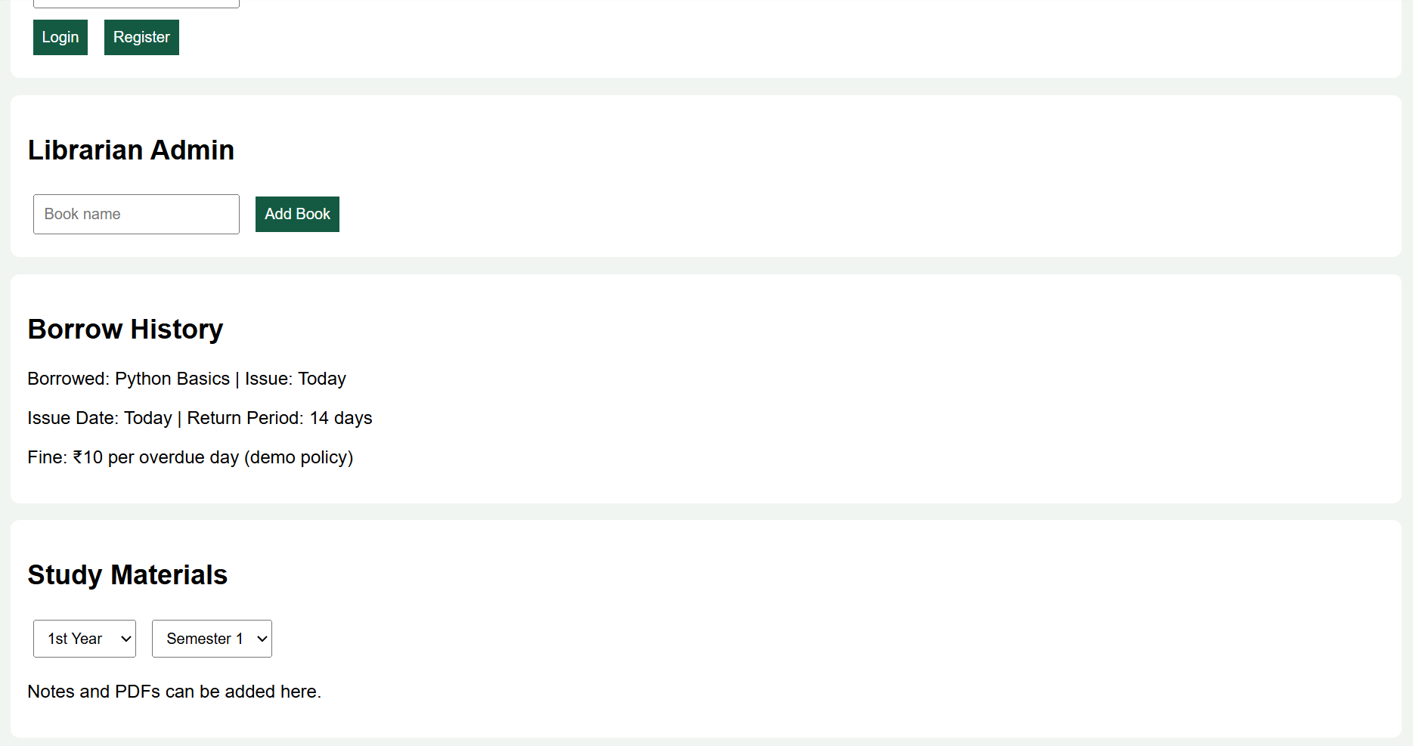

2. Hotel Booking System
SOURCE CODE
```html
<!DOCTYPE html>
<html>
<head>
<title>Hotel Room Booking</title>
<style>
body{font-family:Arial;background:#eef2f3;margin:0;text-align:center}
header{background:#174a5b;color:white;padding:18px}
section{background:white;margin:15px auto;padding:15px;max-width:700px;border-radius:10px}
input,select,button{padding:9px;margin:5px}
button{background:#174a5b;color:white;border:0;cursor:pointer}
</style>
</head>
<body>
<header><h1>Hotel Booking System</h1>
<p>Book your perfect stay!</p></header>
<section>
<h2>Register / Profile</h2>
<input id="user" placeholder="Your Name">
<input id="email" placeholder="Email">
<button onclick="register()">Register</button>
<p id="profile"></p>
</section>
<section>
<h2>Search & Book Rooms</h2>
<input type="date" id="checkin">
<input type="date" id="checkout">
<select id="guests">
<option>1 Guest</option><option>2 Guests</option>
<option>3 Guests</option><option>4 Guests</option>
</select>
<select id="room">
<option>Standard</option><option>Deluxe</option>
<option>Suite</option><option>Family</option>
</select>
<button onclick="book()">Book Room</button>
<p id="result"></p>
</section>
<section>
<h2>Room Details</h2>
<p>Standard - ₹1500 | Deluxe - ₹2500</p>
<p>Suite - ₹4000 | Family - ₹3500</p>
<p>Amenities: Wi-Fi, AC, Restaurant and Room Service</p>
</section>
<section>
<h2>My Booking History</h2>
<div id="history"></div>
</section>
<section>
<h2>Admin Panel</h2>
<select id="adminroom">
<option>Standard</option><option>Deluxe</option>
<option>Suite</option><option>Family</option>
</select><br>
<input type="number" id="price" placeholder="Room price">
<input type="number" id="qty" placeholder="Room quantity">
<button onclick="updateRoom()">Update Room</button>
<p id="adminresult"></p>
</section>
<section>
<h2>About Us & Contact</h2>
<p>Enjoy a comfortable stay with our hotel booking service.</p>
<p>Email: hotel@example.com | Phone: 9876543210</p>
<h3>Customer Service FAQ</h3>
<p>Bookings can be cancelled at least 3 days before arrival.</p>
<h3>Travel Guide</h3>
<p>Ask our reception for nearby tourist attractions and transport.</p>
<h3>Privacy Policy</h3>
<p>Customer details should be kept private and secure.</p>
</section>
<script>
let bookings=[];
let rooms={
Standard:{price:1500,qty:5},
Deluxe:{price:2500,qty:4},
Suite:{price:4000,qty:2},
Family:{price:3500,qty:3}
};
function register(){
profile.innerText="Welcome, "+user.value+" ("+email.value+")";
}
function book(){
let a=checkin.value,b=checkout.value,r=room.value;
if(!user.value||!a||!b||a<new Date().toISOString().slice(0,10)||b<=a){
result.innerText="Enter valid details and register first.";return;
}
if(rooms[r].qty<=0){result.innerText="Room unavailable.";return;}
rooms[r].qty--;
bookings.push({name:user.value,room:r,date:a,end:b});
result.innerText="Booking confirmed! Price per night: ₹"+rooms[r].price;
show();
}
function show(){
history.innerHTML=bookings.map((x,i)=>
`${x.room}: ${x.date} to ${x.end}
<button onclick="cancel(${i})">Cancel</button><br>`).join("");
}
function cancel(i){
let arrival=new Date(bookings[i].date);
let days=(arrival-new Date())/86400000;
if(days<3){alert("Cancellation allowed only 3 days before arrival.");return;}
rooms[bookings[i].room].qty++;
bookings.splice(i,1);show();
}
function updateRoom(){
let r=adminroom.value;
rooms[r].price=Number(price.value)||rooms[r].price;
rooms[r].qty=Number(qty.value)||rooms[r].qty;
adminresult.innerText=r+" room updated successfully.";
}
</script>
</body>
</html>
